Institute of Computer Technology

B. Tech Computer Science and Engineering

Subject: DS (2CSE302)

**PRACTICAL-23**

**AIM: - Implement shell sort and heap sort.**

(This practical is in continuation of previous practical scenario, so append code of below scenario along with previous practical)

**1. Swati is working on different sorting methods to sort the data. She wants to prepare sorting calculator which provides the facilities to sort all kind of sorting methods for same data. Kindly refer given scenario for calculator and implement it in C:**

**How many number you want to sort:**

**8**

**Enter the Elements for Sorting:**

**34**

**22**

**56**

**13**

**89**

**5**

**67**

**45**

**List of sorting methods:**

**1. Bubble Sort**

**2. Insertion Sort**

**3. Selection Sort**

**4. Merge Sort**

**5. Quick Sort**

**6. Radix Sort**

**7. Shell Sort**

**8. Heap Sort**

**9. Exit**

**Which choice do you want apply?**

**7**

**Pass-1 34 5 56 13 89 22 67 45**

**Pass-2 34 5 56 13 67 22 89 45**

**Pass-3 5 13 22 34 45 56 67 89**

***SOLUTION***

#include <stdio.h>

#include <stdlib.h>

int p = 0, q = 0, rm = 0;

void PrintArr(int arr[], int n)

{

for (int i = 0; i < n; i++)

{

printf("%d ", arr[i]);

}

printf("\n");

}

void BubbleSort(int arr[], int m)

{

int i, j, k, temp;

for (i = 0; i < m - 1; i++)

{

for (j = 0; j < m - i - 1; j++)

{

if (arr[j] > arr[j + 1])

{

temp = arr[j];

arr[j] = arr[j + 1];

arr[j + 1] = temp;

}

}

printf("Pass %d: ", i + 1);

for (k = 0; k < m; k++)

{

printf("%d ", arr[k]);

}

printf("\n");

}

}

void InsertionSort(int arr[], int m)

{

int i, j, k, temp;

for (i = 1; i < m; i++)

{

temp = arr[i];

j = i - 1;

while (j >= 0 && arr[j] > temp)

{

arr[j + 1] = arr[j];

j -= 1;

}

arr[j + 1] = temp;

printf("Pass %d: ", i);

for (k = 0; k < m; k++)

{

printf("%d ", arr[k]);

}

printf("\n");

}

}

void SelectionSort(int arr[], int m)

{

int i, j, min, k, temp;

for (i = 0; i < m - 1; i++)

{

min = i;

for (j = i + 1; j < m; j++)

{

if (arr[j] < arr[min])

{

min = j;

}

}

temp = arr[i];

arr[i] = arr[min];

arr[min] = temp;

printf("Pass %d: ", i + 1);

for (k = 0; k < m; k++)

{

printf("%d ", arr[k]);

}

printf("\n");

}

}

void merge(int arr[], int l, int mid, int r)

{

int i, j, k;

int n1 = mid - l + 1;

int n2 = r - mid;

int left[n1], right[n2];

for (i = 0; i < n1; i++)

{

left[i] = arr[l + i];

}

for (j = 0; j < n2; j++)

{

right[j] = arr[mid + 1 + j];

}

i = 0;

j = 0;

k = l;

while (i < n1 && j < n2)

{

if (left[i] < right[j])

{

arr[k] = left[i];

i++;

}

else

{

arr[k] = right[j];

j++;

}

k++;

}

while (i < n1)

{

arr[k] = left[i];

i++;

k++;

}

while (j < n2)

{

arr[k] = right[j];

j++;

k++;

}

}

void MergeSort(int arr[], int l, int r)

{

if (l < r)

{

int mid = (l + r) / 2;

MergeSort(arr, l, mid);

MergeSort(arr, mid + 1, r);

merge(arr, l, mid, r);

printf("Pass %d: ", ++q);

for (rm = 0; rm < p; rm++)

{

printf("%d ", arr[rm]);

}

printf("\n");

}

}

int partition(int arr[], int low, int high)

{

int temp;

int pivot = arr[low];

int i = low + 1;

int j = high;

do

{

while (arr[i] <= pivot)

{

i++;

}

while (arr[j] > pivot)

{

j--;

}

if (i < j)

{

temp = arr[i];

arr[i] = arr[j];

arr[j] = temp;

}

} while (i < j);

temp = arr[low];

arr[low] = arr[j];

arr[j] = temp;

return j;

}

void QuickSort(int arr[], int low, int high)

{

int partitionIndex;

if (low < high)

{

printf("Pass %d: ", ++q);

for (rm = 0; rm < p; rm++)

{

printf("%d ", arr[rm]);

}

printf("\n");

partitionIndex = partition(arr, low, high);

QuickSort(arr, low, partitionIndex - 1);

QuickSort(arr, partitionIndex + 1, high);

}

}

int MaxElement(int arr[], int n)

{

int max = arr[0];

for (int i = 1; i < n; i++)

if (arr[i] > max)

{

max = arr[i];

}

return max;

}

void RadixSort(int arr[], int n)

{

int bucket[10][10], bucket_cnt[10];

int i, j, k, r, NOP = 0, divisor = 1, Max, pass;

Max = MaxElement(arr, n);

while (Max > 0)

{

NOP++;

Max /= 10;

}

for (pass = 0; pass < NOP; pass++)

{

for (i = 0; i < 10; i++)

{

bucket_cnt[i] = 0;

}

for (i = 0; i < n; i++)

{

r = (arr[i] / divisor) % 10;

bucket[r][bucket_cnt[r]] = arr[i];

bucket_cnt[r] += 1;

}

i = 0;

for (k = 0; k < 10; k++)

{

for (j = 0; j < bucket_cnt[k]; j++)

{

arr[i] = bucket[k][j];

i++;

}

}

divisor *= 10;

printf("Pass %d : ", pass + 1);

for (i = 0; i < n; i++)

{

printf("%d ", arr[i]);

}

printf("\n");

}

}

void ShellSort(int arr[], int n)

{

for (int interval = n / 2; interval > 0; interval /= 2)

{

for (int i = interval; i < n; i++)

{

int temp = arr[i];

int j;

for (j = i; j >= interval && arr[j - interval] > temp; j -= interval)

{

arr[j] = arr[j - interval];

}

arr[j] = temp;

}

printf("Pass %d: ", ++q);

PrintArr(arr, n);

}

printf("\n");

}

void Heapify(int arr[], int n, int i)

{

int largest = i;

int left = 2 * i + 1;

int right = 2 * i + 2;

if (left < n && arr[left] > arr[largest])

{

largest = left;

}

if (right < n && arr[right] > arr[largest])

{

largest = right;

}

if (largest != i)

{

int temp = arr[i];

arr[i] = arr[largest];

arr[largest] = temp;

Heapify(arr, n, largest);

}

}

void HeapSort(int arr[], int n)

{

for (int i = n / 2 - 1; i >= 0; i--)

{

Heapify(arr, n, i);

}

for (int i = n - 1; i >= 0; i--)

{

int temp = arr[0];

arr[0] = arr[i];

arr[i] = temp;

Heapify(arr, i, 0);

printf("Pass %d: ",++q);

PrintArr(arr,n);

}

}

int main()

{

int n, i, choice;

printf("\nEnter number of elements you want to sort: ");

scanf("%d", &n);

p = n;

int yash[n], prajapati[n], selectionarr[n], mergearr[n], quickarr[n], radixarr[n], shellarr[n], heaparr[n];

printf("\nEnter the Elements for Sorting: ");

for (i = 0; i < n; i++)

{

scanf("%d", &yash[i]);

prajapati[i] = yash[i];

selectionarr[i] = yash[i];

mergearr[i] = yash[i];

quickarr[i] = yash[i];

radixarr[i] = yash[i];

shellarr[i] = yash[i];

heaparr[i] = yash[i];

}

there:

printf("\nList of sorting methods: \n1. Bubble Sort\n2. Insertion Sort\n3. Selection Sort\n4. Merge Sort");

printf("\n5. Quick Sort\n6. Radix Sort\n7. Shell Sort\n8. Heap Sort\n9. Exit");

printf("\n\nWhich choice do you want to apply? ");

scanf("%d", &choice);

switch (choice)

{

case 1:

printf("\nBefore Bubble Sort : ");

PrintArr(yash, n);

BubbleSort(yash, n);

printf("\nAfter Bubble Sort : ");

PrintArr(yash, n);

goto there;

break;

case 2:

printf("\nBefore Insertion Sort : ");

PrintArr(prajapati, n);

printf("\n");

InsertionSort(prajapati, n);

printf("\nAfter Insertion Sort : ");

PrintArr(prajapati, n);

goto there;

break;

case 3:

printf("\nBefore Selection Sort : ");

PrintArr(selectionarr, n);

printf("\n");

SelectionSort(selectionarr, n);

printf("\nAfter Selection Sort : ");

PrintArr(selectionarr, n);

goto there;

break;

case 4:

printf("\nBefore Merge Sort : ");

PrintArr(mergearr, n);

printf("\n");

MergeSort(mergearr, 0, n - 1);

printf("\nAfter Merge Sort : ");

PrintArr(mergearr, n);

goto there;

break;

case 5:

printf("\nBefore Quick Sort : ");

PrintArr(quickarr, n);

printf("\n");

QuickSort(quickarr, 0, n - 1);

printf("\nAfter Quick Sort : ");

PrintArr(quickarr, n);

goto there;

break;

case 6:

printf("\nBefore Radix Sort : ");

PrintArr(radixarr, n);

printf("\n");

RadixSort(radixarr, n);

printf("\nAfter Radix Sort : ");

PrintArr(radixarr, n);

goto there;

break;

case 7:

printf("\nBefore Shell Sort : ");

PrintArr(shellarr, n);

printf("\n");

ShellSort(shellarr, n);

printf("\nAfter Shell Sort : ");

PrintArr(shellarr, n);

goto there;

break;

case 8:

printf("\nBefore Heap Sort : ");

PrintArr(heaparr, n);

printf("\n");

HeapSort(heaparr, n);

printf("\nAfter Heap Sort : ");

PrintArr(heaparr, n);

goto there;

break;

case 9:

exit(0);

break;

default:

printf("\nInvalid choice. Enter Again!");

goto there;

break;

}

printf("\n");

return 0;

}

***OUTPUT* (Shell Sort)**

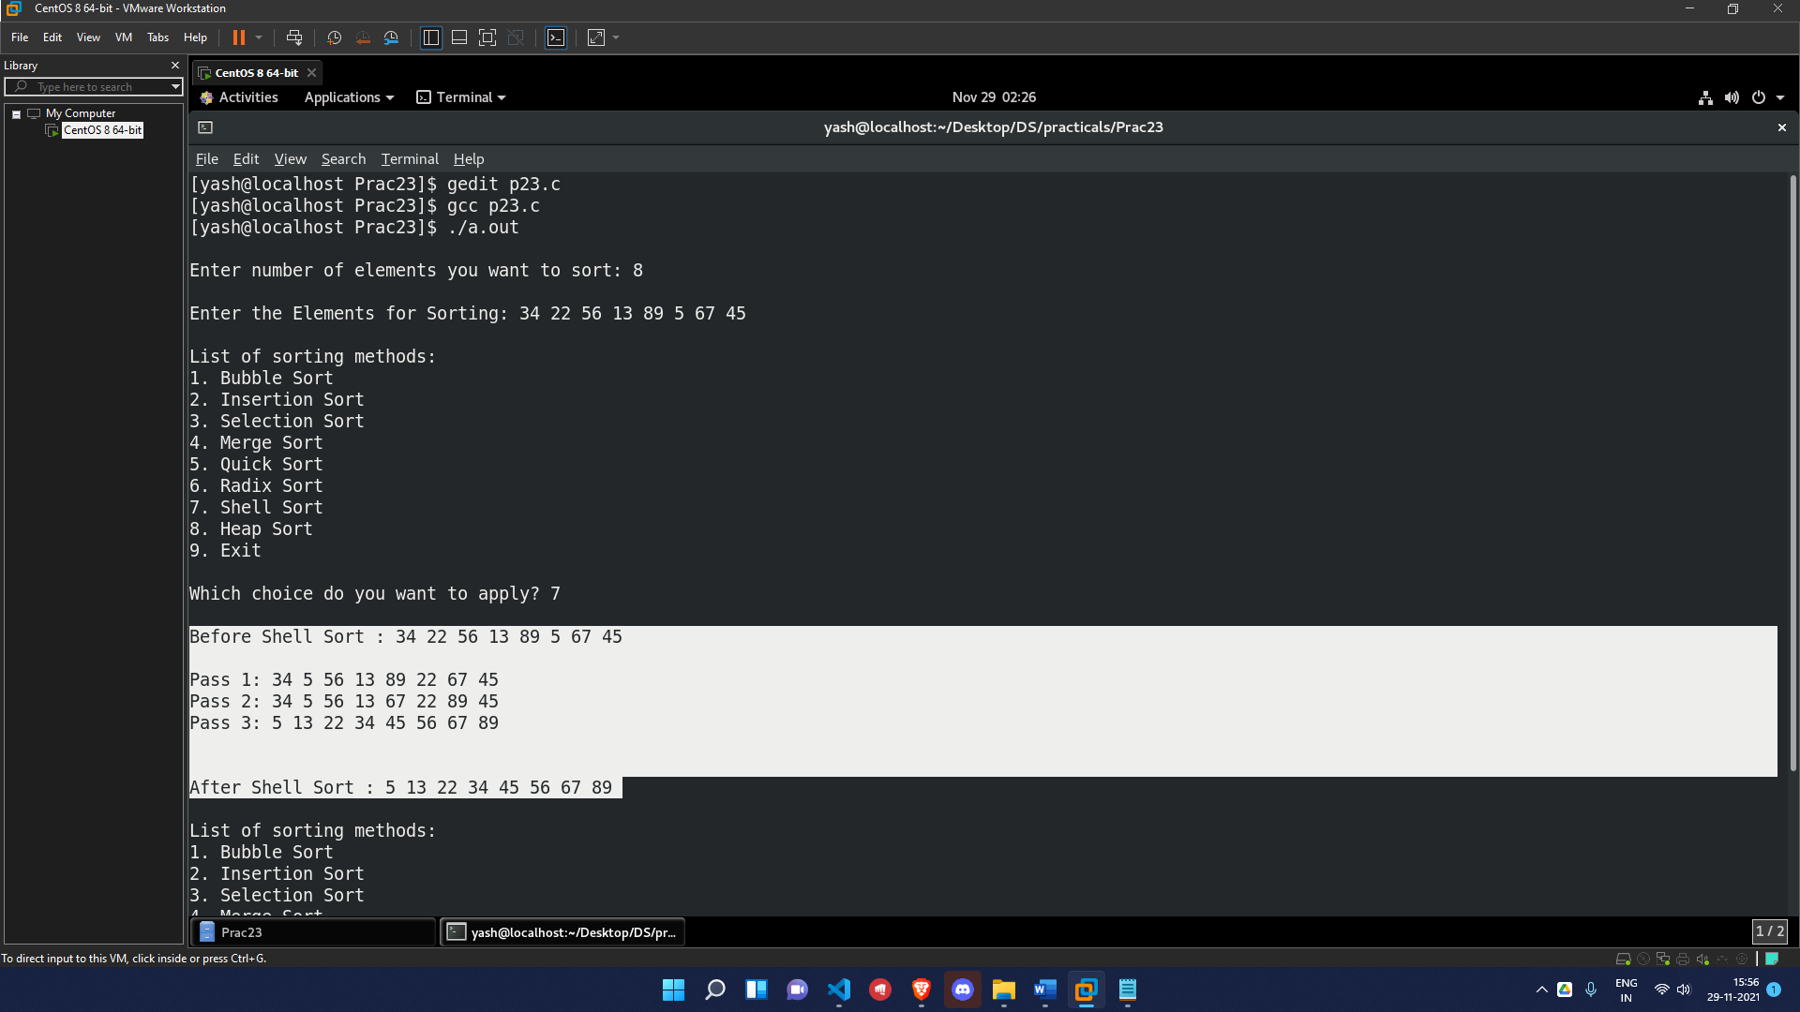

***OUTPUT* (Heap Sort)**

